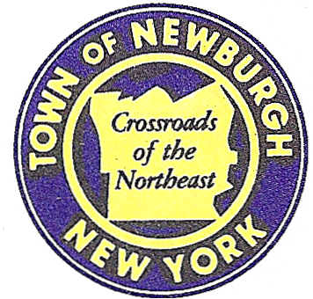

TOWN OF NEWBURGH
--------Crossroads of the Northeast _
OLD TOWN HALL
308 GARDNERTOWN ROAD NEWBURGH, NEW YORK 12550

PLANNING BOARD
JOHN P. EWASUTYN, CHAIRMAN TELEPHONE 845-564-7804
FAX 845-564-7802
E-MAIL: planningboard@townofnewburgh.org

PLANNING BOARD AGENDA

APRIL 17, 2014

**PLEASE NOTE: The Planning Board Meeting will start at 7:00 P.M. and all Applicants/Representatives are to be present at that time. The Meeting will be held in the Meeting Room of Town Hall, located at 1496 Route 300, Newburgh NY.**

- Marketplace at Newburgh (2004-54)  Rt. 300 & Rt. 52  Section, Block, Lot: Multiple  Zone: IB  Rep: John Bainlardi  Wilder Balter Partners  570 Taxter Road, 6th Floor  Elmsford, NY 10523 | AMENDED SITE PLAN
- Colandrea Sunshine Ford (2013-24)  40 Route 17K  Section 99, Block 4, Lots 4-11, 23 & 18  Zone: IB  Rep: Shaw Engineering  81 Balmville Road  Newburgh, NY 12550 | AMENDED SITE PLAN

*WORK SESSION: Project Readiness Discussion scheduled for 5:30 p.m. in the Meeting Room of Town Hall on Thursday, April 17, 2014*

AMENDED PLANNING BOARD BUSINESS
WORK SESSION

APRIL 17, 2014
5:30 P.M.

Discussion:

- Gardnertown Commons (2009-12):
The Applicant is requesting a one year extension of conditional site plan approval from
19 May 2014 to 19 May 2015.

- NYC DEP Delaware Aqueduct Repair (2011-15):
Discussion of material leaving site to the north.

